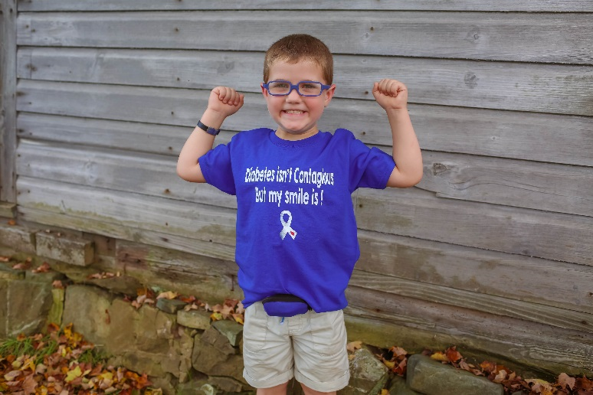

Dear business owner,
I am writing to you to request a charitable donation for the Second Annual Golfing for Gavin Fundraiser to be held on Monday, September 10, 2018 at Burden Lake Country Club. Proceeds from this golf tournament will go to the Guiding Gavin/JDRF 2019 One Walk.
Gavin was diagnosed with type 1 diabetes on September 20, 2015 at the young age of 2 ½. As anyone can imagine, this came as a huge shock. This lifelong disease could not have stricken this sweet little boy, but it did. Since that diagnosis, life has been filled with up’s and down’s BUT through it all, he has shown a strength that has surpassed any expectations that anyone could have imagined. He has completed kindergarten and will be attending a week at the Sand Lake Day Camp in the summer. He is a trooper and his family cannot be more proud of him.
JDRF is the leading global organization funding type 1 diabetes (T1D) research. Their strength lies in the exclusive focus and singular influence on the worldwide effort to end T1D. For more information, please visit the website, http://www.jdrf.org/.
We are requesting a donation of a product or service to be used in support of the event. We are also asking for hole sponsors. Each hole donation is $100. We thank you in advance for your time and consideration. Checks should be written to Guiding Gavin / JDRF and sent to Kristie Smith-Trudell, 11 Coyote Lane, Troy NY 12180.
Thank you for considering a donation towards the work of ‘Turning Type 1 into Type NONE’.
Please send any questions to guidinggavin0920@gmail.com.

Warmly,
Kristie Smith-Trudell
Guiding Gavin / JDRF Organizer

